Software Requirements Specification (SRS)
ReqBot – AI Powered Business Analyst
Version 1.0
Prepared by: Waleed ( 02-131242-119 )

1. Introduction
1.1 Purpose
This document constitutes the Software Requirements Specification (SRS) for ReqBot, an AI-powered web application designed to function as an automated Business Analyst. It provides a complete and unambiguous description of the system's required capabilities, external interfaces, and quality attributes. The primary purpose of this document is to serve as a foundational agreement between stakeholders—including clients, project managers, software developers, and testers—and to provide a detailed blueprint for the design, implementation, and verification of the system. ReqBot aims to revolutionize the requirements engineering phase of the software development lifecycle by leveraging advanced conversational AI to make professional-grade requirement elicitation and documentation accessible to a broad audience, thereby reducing initial project ambiguity and mitigating downstream development risks.
1.2 Document Conventions
This SRS adheres to the following conventions:
- Prioritization: Functional and non-functional requirements are assigned a priority level of High (H), Medium (M), or Low (L). High-priority requirements are considered mandatory for the Minimum Viable Product (MVP), Medium-priority are important but can be deferred, and Low-priority are enhancement-level features.
- Requirement Identification: Functional requirements are uniquely identified using the pattern FR-XX-Y, where FR stands for Functional Requirement, XX is a two-letter code for the feature area (e.g., CONV for Conversation), and Y is a sequential number.
- Typography: Key terms, especially upon their first occurrence, are emphasized in italics. System features and external entities are presented in bold.
- Traceability: Each requirement is structured to be discrete, testable, and traceable through to design elements and test cases via the Traceability Matrix in Appendix D.
1.3 Intended Audience and Reading Suggestions
This document is intended for:
- Developers and System Architects: To understand the system's functional and technical specifications for design and implementation. They should focus on Sections 2, 3, and 4.
- Testers and QA Engineers: To derive test plans, test cases, and validation criteria. They should focus on Sections 3, 4, and 5, and Appendix D.
- Project Managers: To plan project milestones, allocate resources, and track progress against requirements. They should focus on Sections 1, 2, and 5.
- Stakeholders and Clients: To gain a comprehensive understanding of the system's scope, capabilities, and constraints. They should read Sections 1 and 2 in their entirety.
- All readers are advised to begin with the Introduction (Section 1) and Overall Description (Section 2) to establish context before proceeding to the more detailed technical specifications.
1.4 Product Scope
ReqBot is a standalone Software-as-a-Service (SaaS) web application that addresses the critical and pervasive challenge of ambiguous, incomplete, or poorly documented software requirements. The product leverages a conversational interface powered by a Large Language Model (LLM) to guide users through the requirement elicitation process, automatically analyze the conversation to extract and categorize requirements, and generate comprehensive, professional documentation. Its purpose is to democratize the practice of requirements engineering, making it accessible to individuals without formal training while significantly accelerating the process for experienced professionals. The core value proposition lies in transforming informal, natural language discussions into structured, actionable software specifications, thereby improving project clarity, reducing rework, and enhancing communication between technical and non-technical stakeholders. This product aligns with the strategic business goal of utilizing artificial intelligence to optimize and automate key phases of the software development lifecycle.

1.5 References
- IEEE Std 830-1998, IEEE Recommended Practice for Software Requirements Specifications. IEEE, 1998.
- Next.js Foundation, Next.js 14 Documentation, Vercel, 2024. [Online]. Available: https://nextjs.org/docs
- Google LLC, Genkit Framework Documentation, 2024. [Online]. Available: https://firebase.google.com/docs/genkit
- Google LLC, Google AI Gemini API Documentation, 2024. [Online]. Available: https://ai.google.dev/
- World Wide Web Consortium (W3C), Web Content Accessibility Guidelines (WCAG) 2.1, 2018. [Online]. Available: https://www.w3.org/TR/WCAG21/
- Mermaid.js Community, Mermaid.js Documentation, 2024. [Online]. Available: https://mermaid.js.org/

2. Overall Description
2.1 Product Perspective
ReqBot is conceived as a new, self-contained product within the ecosystem of modern AI-powered productivity tools. It is not a component of a larger system nor a replacement for an existing one; rather, it introduces a novel paradigm for requirement gathering. The system operates on a serverless architecture, clearly separating the client-side user interface from the server-side AI processing logic. The frontend is a single-page application built with the Next.js framework, which is served to the user's web browser. The backend consists of serverless functions, primarily utilizing the Genkit framework to orchestrate interactions with the Google Gemini LLM API. All conversation data is persisted locally within the user's browser using the localStorage API, ensuring privacy and session continuity. The system's external environment consists of the user's browser, the public internet, and the Google AI services, with which it communicates securely via HTTPS.
2.2 Product Functions
The high-level functionalities of ReqBot are summarized as follows:
- Intelligent Conversational Interface: To engage users in a natural, context-aware dialogue for the purpose of eliciting software project requirements, mimicking the probing and clarifying behavior of a human business analyst.
- Multi-Modal Input Handling: To accept user input through both text-based typing and real-time voice transcription, thereby accommodating different user preferences and enhancing accessibility.
- Automated Requirement Analysis: To process the conversation context using AI to automatically identify, extract, and categorize discrete requirements into standard classifications such as Functional, Non-Functional, Domain, and Inverse requirements.
- Dynamic Documentation Generation: To compile all analysed data, conversation history, and AI-generated insights into a professionally formatted report, complete with visual diagrams (e.g., process flows) and speculative project estimations, available for export.
- Adaptive User Experience: To provide a responsive, theme able, and accessible web interface that delivers a consistent and intuitive experience across various device types and user abilities.
2.3 User Classes and Characteristics
- Software Developers: Technically proficient individuals focused on implementation. They require clear, unambiguous, and testable specifications. They are characterized by a low tolerance for ambiguity and a high frequency of use during the initial project scoping phase.
- Business Analysts: Domain experts with experience in traditional requirements engineering. They value structured outputs, stakeholder communication aids, and the ability to validate and refine AI-generated requirements. They are the most critical user class for ensuring the quality of the output.
- Product Managers: Strategically-oriented users responsible for feature definition and roadmapping. They benefit from high-level summaries, visual diagrams for presentation, and speculative estimations for planning. Their usage may be less frequent but is highly impactful for decision-making.
- Students: Users with an academic focus on software engineering or business analysis. They use the system primarily for learning and understanding the principles and artifacts of requirements engineering. They require educational clarity and illustrative examples.
2.4 Operating Environment
- Software Platform: The application is a web-based system requiring a modern web browser. Supported browsers include the latest two stable versions of Google Chrome, Mozilla Firefox, Apple Safari, and Microsoft Edge.
- Operating Systems: The application is platform-agnostic and will operate on any system capable of running a supported browser, including Windows 10+, macOS 10.15+, mainstream Linux distributions, iOS 14+, and Android 10+.
- External Dependencies:
  - Server-Side: Node.js runtime environment for executing serverless functions. The Google Gemini LLM API is a critical external dependency for all AI processing.
  - Client-Side: The user's browser must support JavaScript (ES6+), CSS Grid/Flexbox, and the Web Speech API for voice input functionality.
2.5 Design and Implementation Constraints
- Architectural Constraint: The system shall be implemented as a Next.js application using the App Router architecture, enforcing a React-based, server-rendered frontend with API routes for backend logic.
- AI Framework Constraint: All interactions with the LLM shall be mediated through the Genkit framework to ensure a structured, type-safe, and maintainable approach to AI flow management.
- Frontend Technology Stack: The user interface shall be constructed using React with TypeScript for type safety, and styled using Tailwind CSS in conjunction with the ShadCN/UI component library to ensure a consistent and accessible design system.
- Security Constraint: Under no circumstances shall API keys or other sensitive credentials for external services (e.g., Google AI) be exposed to the client-side code. All such interactions must be handled via server-side functions or API routes.
- Deployment Constraint: The application must be deployable and fully operational on the Vercel cloud platform, leveraging its serverless functions and global CDN.
- Data Persistence Constraint: User data, including conversation history, shall be persisted exclusively on the client-side using the browser's localStorage mechanism, with no initial requirement for a centralized database.

2.6 User Documentation
The following user documentation shall be delivered alongside the software:
- Integrated User Guide: A context-sensitive help system accessible from within the application, providing guidance on how to conduct effective requirement conversations and interpret generated reports.
- Technical Setup Guide: Documentation aimed at developers, detailing the steps for local environment setup, build procedures, and deployment configuration for the Vercel platform.
2.7 Assumptions and Dependencies
- Assumptions:
  - It is assumed that the user has a stable and continuous internet connection for the duration of AI processing interactions.
  - It is assumed that the user possesses a basic conceptual understanding of software projects and can articulate their needs in natural language.
  - It is assumed that the Google Gemini API will maintain a service level with high availability and consistent, low-latency response times.
- Dependencies:
  - The core AI functionality is critically dependent on the continued service, performance, and API stability of the Google Gemini LLM.
  - The voice input feature is dependent on the user's browser supporting and having access to the Web Speech API.
  - The deployment and scaling of the application are dependent on the features and reliability of the Vercel platform.
  - The development tool chain is dependent on the Node.js ecosystem and the availability of the specified frameworks (Next.js, Genkit, etc.).

3. External Interface Requirements
3.1 User Interfaces
The User Interface (UI) shall be a clean, minimalist, single-page web application designed to prioritize the conversational workflow. The primary interface components are:
- Application Header: A persistent header containing the application logo, a button to generate reports, a theme toggle (light/dark mode), and a link to settings/help.
- Conversation Panel: The central area of the application, displaying the entire message history in a chronological, thread-like view. User messages shall be visually distinguished from AI responses through alignment (e.g., user on the right, AI on the left) and distinct color schemes.
- Input Area: A fixed bar at the bottom of the screen containing a text input field, a submit button, and a microphone icon button to toggle voice input. When voice input is active, a prominent visual indicator (e.g., a pulsating red circle) shall be displayed.
- Status Indicators: The UI shall provide clear, non-intrusive feedback for system states, including a "Connecting..." indicator for initial load, a "Thinking..." animation during AI processing, and toast notifications for events like conversation saved or report generated.
- Report Modal: A modal window that appears upon report generation, displaying the formatted report with a clear option to "Export as PDF".
The UI shall be fully responsive, ensuring an optimal and fully functional layout on devices ranging from mobile phones to large desktop monitors . The interface shall comply with WCAG 2.1 Level AA guidelines, providing sufficient color contrast, keyboard navigability, and ARIA labels for screen readers.

3.2 Hardware Interfaces
- Minimum Requirements: The system requires a computing device with a modern multi-core, a minimum of 4GB of RAM, and a display .
- Input Devices: Standard input devices including a keyboard and mouse are required. For the core text-based functionality, a microphone is not required.
- Voice Input Hardware: To utilize the voice input features, the user's device must be equipped with a functional microphone.
3.3 Software Interfaces
- Google Gemini API:
  - Identity: Primary external AI service provider.
  - Interaction Method: The Next.js server-side API routes (or server actions) will make HTTPS requests to the Gemini API endpoints. The Genkit framework will be used to structure these requests and parse the responses.
  - Data Format: All requests and responses will use JSON payloads. The request payload will contain a structured prompt including the conversation history and specific instructions for requirement analysis.
  - Purpose: This interface is responsible for all natural language understanding, context management, requirement extraction, and text generation.
- Browser Web Speech API:
  - Identity: Client-side API for speech recognition.
  - Interaction Method: The React application will access this API via JavaScript (window.SpeechRecognition or window.webkitSpeechRecognition).
  - Purpose: To convert user's spoken words into text in real-time, which is then fed into the main chat input field.
3.4 Communications Interfaces
- Primary Protocol: All client-server and server-to-external-API communication shall be conducted over HTTPS, utilizing TLS 1.2 or higher to ensure encryption in transit.
- Data Interchange Format: JavaScript Object Notation (JSON) shall be the standard data format for all API request and response bodies, using UTF-8 character encoding.
- Authentication: Communication with the Google Gemini API shall be authenticated using an API key. This key shall be stored as an environment variable on the server (Vercel) and included in the Authorization header of the HTTPS request {.env file} .

4. System Features
This section details the major functional areas of the system, organized by feature.
4.1 Conversational Elicitation Feature
4.1.1 Description and Priority
This feature provides the core interactive mechanism of ReqBot: a natural language chat interface that allows users to discuss their software project needs as if they were speaking with a human business analyst. The system is designed to maintain context over a long conversation, ask clarifying questions, and progressively build a detailed understanding of the project. This is the fundamental interaction model for the entire application.
Priority: High
4.1.2 Stimulus/Response Sequences
- Stimulus: User launches the application in their browser.
- Response: System loads the chat interface, displays a welcome message, and prompts the user to describe their project.
- Stimulus: User types a message describing a feature (e.g., "I need a login system for my web app") and presses Enter or clicks "Send".
- Response: System displays the user's message in the conversation panel, shows a "Thinking..." indicator, processes the message via the AI service, and then displays the AI's response (e.g., "Okay, for the login system, should it support logging in with social media accounts like Google or Facebook?").
- Stimulus: User clicks a "New Conversation" button.
- Response: System displays a confirmation dialog. Upon user confirmation, it clears the current conversation history from the UI and localStorage, and re-initializes to the welcome state.
4.1.3 Functional Requirements
- FR-CONV-1: The system shall provide a text input field and a mechanism for the user to submit text messages to the conversation. (High)
- FR-CONV-2: The system shall display a visual indicator (e.g., an animated ellipsis) within the conversation thread whenever the AI is processing a user message and preparing a response. (Medium)
- FR-CONV-3: The system shall maintain the full history of the current conversation, including both user and AI messages with accurate timestamps, for the duration of the browser session. (High)
- FR-CONV-4: The system shall automatically save the conversation state to the browser's localStorage after each message exchange, allowing the conversation to be resumed exactly where it left off if the browser is closed and reopened. (High)
- FR-CONV-5: The system shall provide a clearly labeled "New Conversation" control which, when activated, prompts the user for confirmation before permanently deleting the current conversation and starting a new one. (Medium)
4.2 Multi-Modal Input Processing Feature
4.2.1 Description and Priority
This feature enhances the accessibility and usability of the application by allowing users to provide input via speech in addition to text. It leverages the browser's native Web Speech API to capture audio, transcribe it to text in real-time, and populate the main chat input field, giving the user an opportunity to review and edit the transcription before sending it.
Priority: Medium
4.2.2 Stimulus/Response Sequences
- Stimulus: User clicks and holds the microphone icon button in the input area.
- Response: System changes the microphone icon to a "stop" or "recording" icon, displays a pulsating visual indicator, and begins capturing audio from the user's microphone.
- Stimulus: User speaks a sentence (e.g., "The user should be able to reset their password by clicking a forgot password link").
- Response: System transcribes the audio in real-time, displaying the transcribed text in the input field as it is recognized.
- Stimulus: User releases the microphone button.
- Response: System stops audio capture, hides the recording indicator, and leaves the fully transcribed text in the input field, ready for the user to edit or send.
4.2.3 Functional Requirements
- FR-VOICE-1: The system shall, upon user activation of the microphone control, request microphone permissions from the browser and, if granted, begin capturing audio input. (Medium)
- FR-VOICE-2: The system shall provide a clear and persistent visual indicator on the screen for the entire duration that voice recording is active. (Medium)
- FR-VOICE-3: The system shall utilize the Web Speech API to convert captured speech into text and stream the results into the text input field in near real-time. (Medium)
- FR-VOICE-4: The system shall place the final transcribed text into the input field upon cessation of recording, requiring an explicit user action (e.g., pressing "Send") to submit it, thereby allowing for manual correction. (High)
- FR-VOICE-5: The system shall gracefully handle errors, such as denied microphone permissions or speech recognition failures, by displaying a user-friendly error message and falling back to the standard text input mode. (Medium)
4.3 AI-Powered Requirement Analysis Feature
4.3.1 Description and Priority
This is the core analytical engine of ReqBot. It processes the entire conversation context using the LLM to automatically identify discrete software requirements, classify them according to a standard taxonomy, and present them in a structured format. This feature transforms an unstructured conversation into a formalized set of specifications.
Priority: High
4.3.2 Stimulus/Response Sequences
- Stimulus: The user provides substantial project context through the conversation (e.g., after several message exchanges about a "user registration" feature).
- Response: The system, as part of its conversational response, may explicitly list and categorize requirements it has identified (e.g., "I've identified a functional requirement: FR-1: The system shall allow a new user to register for an account using an email and password.").
- Stimulus: The user sends a message: "Show me all the requirements we've discussed so far."
- Response: The system generates and displays a consolidated, structured list of all extracted requirements, grouped by category (Functional, Non-Functional, etc.), within the chat thread.
4.3.3 Functional Requirements
- FR-EXTRACT-1: The system shall analyze the entire context of the ongoing conversation to identify statements that constitute software requirements. (High)
- FR-EXTRACT-2: The system shall categorize each identified requirement into one of the following types: Functional, Non-Functional (e.g., performance, security), Domain-specific, or Inverse (what the system shall not do). (High)
- FR-EXTRACT-3: For each extracted requirement, the system shall assign and display a confidence score (e.g., "High/Medium/Low") to indicate the AI's certainty in its interpretation. (Low)
- FR-EXTRACT-4: The system shall allow the user to manually edit the textual content and assigned category of any AI-extracted requirement from within the conversation interface or a dedicated summary view. (Medium)
- FR-EXTRACT-5: The system shall incorporate user feedback and corrections into its analytical model for the remainder of the session, leading to improved accuracy in subsequent requirement extractions. (Medium)
4.4 Automated Documentation Generation Feature
4.4.1 Description and Priority
This feature compiles the entire output of the requirement elicitation and analysis process into a comprehensive, professional, and downloadable Software Requirements Specification document. It automates the creation of reports that include executive summaries, visual diagrams, and project estimations, saving users significant manual effort.
Priority: High
4.4.2 Stimulus/Response Sequences
- Stimulus: User clicks the "Generate Report" button in the application header.
- Response: System displays a "Generating Report..." progress indicator, processes the conversation history and extracted requirements, and then opens a modal window displaying the fully formatted report.
- Stimulus: User clicks the "Export as PDF" button within the report modal.
- Response: System converts the HTML report into a PDF file and triggers a browser download dialog for the user to save the file locally.
- Stimulus: User provides a description of a multi-step process (e.g., "The user logs in, then if they are an admin, they see a dashboard...").
- Response: The generated report includes a Mermaid.js activity diagram that visually represents the described workflow.
4.4.3 Functional Requirements
- FR-REPORT-1: The system shall compile a narrative executive summary from the conversation context, succinctly describing the project's purpose and key features. (High)
- FR-REPORT-2: The system shall automatically generate Mermaid.js syntax from descriptions of processes and system interactions within the conversation, and render these as visual activity diagrams within the report. (High)
- FR-REPORT-3: The system shall provide a speculative estimation of development cost and timeline, calculated heuristically based on the number, type, and perceived complexity of the extracted requirements. (Medium)
- FR-REPORT-4: The system shall format the final report using a professional, clean, and readable template that includes a table of contents, section headers, and consistent typography. (Medium)
- FR-REPORT-5: The system shall provide a one-click option to export the generated report as a PDF document, preserving all formatting and diagrams. (Medium)

5. Other Nonfunctional Requirements
5.1 Performance Requirements
- Application Load Time: The initial load time of the web application shall be less than 3 seconds on a standard broadband connection.
- AI Response Time: The time between a user submitting a message and the full AI response being displayed in the chat interface shall be less than 5 seconds for 90% of the requests under normal load conditions.
- Report Generation Time: The generation and display of a comprehensive report for a conversation containing up to 50 message exchanges shall be completed within 10 seconds.
- Client-Side Responsiveness: The user interface shall remain fully responsive at all times, with all user interactions (clicking buttons, scrolling, typing) providing immediate visual feedback.
- Data Throughput: The system shall be optimized to handle conversation histories of up to 10,000 words without any degradation in UI performance or report generation time.

5.2 Safety Requirements
- Critical Systems Disclaimer: The system shall not be used for eliciting requirements for safety-critical systems, including but not limited to medical devices, aviation control systems, or nuclear energy management. A clear disclaimer to this effect shall be displayed within the application's footer and within all generated reports.
- Error Containment: In the event of an unexpected error or system failure, the application shall fail gracefully, ensuring that no corrupt data is saved and that the user is presented with a clear, non-technical error message and recovery instructions.
5.3 Security Requirements
- Data Confidentiality: All data in transit between the client, the server, and external APIs (Google AI) shall be encrypted using TLS 1.2 or higher.
- Credential Security: API keys and other sensitive credentials for external services shall be stored exclusively in server-side environment variables and must never be embedded in client-side code or transmitted to the client.
- Data Privacy: Since all conversation data is stored in the user's browser localStorage, the application's architecture inherently protects user privacy. The privacy policy shall clearly state that conversation data is not transmitted to or stored on any server owned by the development team, except temporarily in serverless function memory for the purpose of AI processing.
- Session Isolation: The application shall be designed such that there is no possibility of one user's data being exposed to another user, as there is no shared server-side session or database in the initial release.
5.4 Software Quality Attributes
- Availability: The application shall achieve 99.5% uptime during core business hours, excluding scheduled maintenance windows announced at least 48 hours in advance.
- Reliability“The system’s main functions should fail less than 1% of the time. Temporary external errors (like AI API) will be retried up to 3 times with clear fallback messages.”
- Usability: A novice user, upon first launching the application, shall be able to successfully complete a basic requirement elicitation conversation and generate a report without referring to external documentation or help.
- Maintainability: The codebase shall be 100% written in TypeScript. The code shall be structured into modular components and functions with clear APIs and comprehensive inline documentation.
- Portability: The web application shall function identically in terms of features and user experience across the latest two versions of the target browsers (Chrome, Firefox, Safari, Edge) on their respective operating systems.

5.5 Business Rules
- BR-1: All cost and timeline estimations generated by the AI are explicitly non-binding, for informational and planning purposes only, and shall be clearly labeled as "Speculative Estimates" in all outputs.
- BR-2: A single conversation session is logically scoped to a single, discrete software project or a major feature within a larger project. The "New Conversation" action is the mechanism for scoping a new project.
- BR-3: The AI shall be instructed to maintain a neutral, analytical, and professional tone throughout all interactions and shall avoid making subjective recommendations about technology stacks or implementation approaches unless explicitly asked by the user.

6. Other Requirements
- Accessibility: The application shall conform to the Web Content Accessibility Guidelines (WCAG) 2.1 at Level AA. This includes providing keyboard navigation, screen reader support, sufficient color contrast, and resizable text.
- Internationalization: The application's core UI and generated reports shall be in American English. The architecture shall be prepared for future internationalization, with UI text strings isolated for potential translation.
- Legal and Compliance: The application shall be accompanied by a Terms of Service and Privacy Policy that clearly outline data handling practices, AI-generated content disclaimers, and user responsibilities.
- Analytics : The app will use a simple, privacy-safe analytics service (like Plausible) to track anonymous user activity and performance, following the privacy rules.”

Appendix A: Glossary
Term | Short Definition
AI | Machines simulating human intelligence; here, using LLMs to understand/generate language.
LLM | AI model (like Google Gemini) trained on huge text/code datasets for human-like language tasks.
Genkit | Open-source framework by Google to build and manage AI workflows.
Next.js | React-based web framework with server-side rendering and routing.
SRS | Document describing software purpose, environment, and behavior.
API | Rules for software components to communicate.
Web Speech API | JavaScript API for speech recognition and synthesis in browsers.
Mermaid.js | JS tool to create diagrams from text.
MVP | Basic product version with core features for early release and feedback.
SaaS | Software accessed online via subscription instead of installed locally.

Appendix B: Analysis Models
(This appendix would contain the detailed diagrams referenced throughout the document, such as:)
Figure 2.1: System Context Diagram
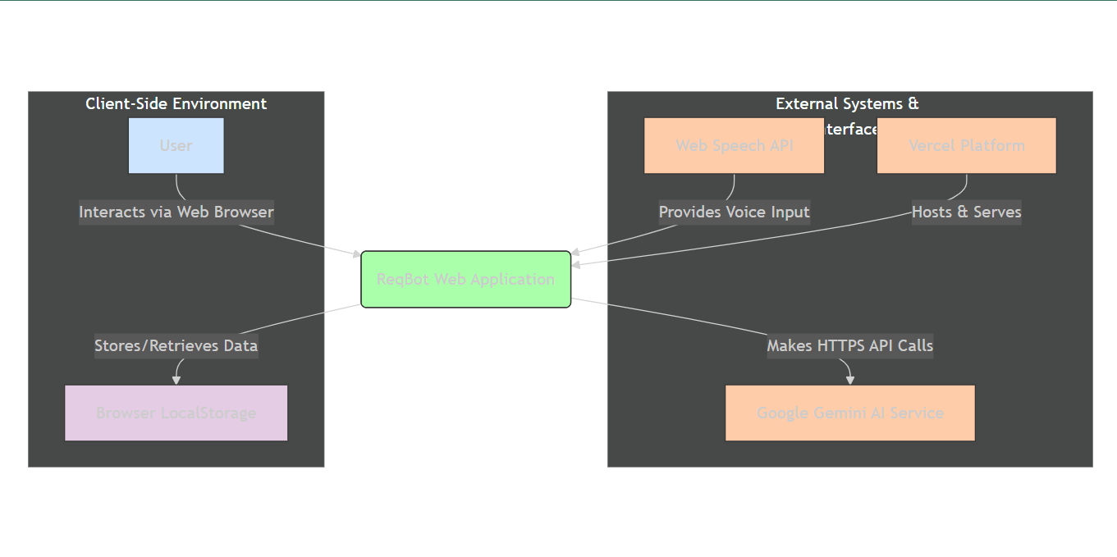
Figure 2.2: High-Level Use Case Diagram
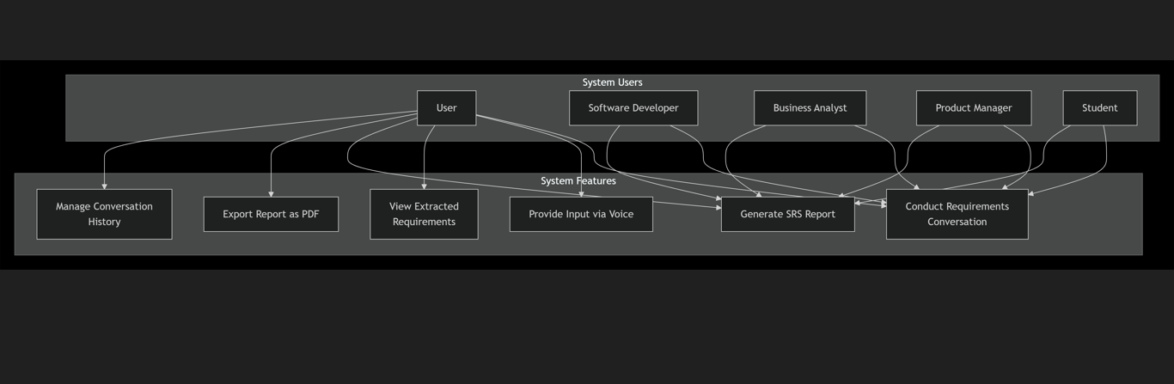

Figure 3.1: Detailed Use Case
Use Case 1: Conduct Requirements Conversation
Field | Content
ID | UC1
Short ID | CONV
Name | Conduct Conversation
Full Name | Conduct Requirements Conversation
Description | User interacts with ReqBot via natural language dialogue to discuss, define, and refine software project requirements
Pre-condition | - ReqBot system is running and accessible  - User has a software project to discuss  - Browser supports required JavaScript features
Event Flow | 1. System presents conversation interface  2. User describes project requirements via text input  3. System processes input and generates contextual response  4. System may ask clarifying questions  5. Steps 2-4 repeat until requirements are sufficiently detailed  6. System automatically extracts and categorizes requirements
Post-condition | - Requirements are extracted and categorized  - Conversation history is preserved  - User can generate formal documentation
Includes | UC2 (Provide Voice Input)  UC3 (View Extracted Requirements)
Extensions | - User may switch to voice input at step 2  - User may review extracted requirements during conversation
Triggers | User initiates new conversation or continues existing session

Use Case 2: Provide Voice Input
Field | Content
ID | UC2
Short ID | VOICE
Name | Voice Input
Full Name | Provide Input via Voice
Description | User provides requirements input through speech recognition instead of manual typing
Pre-condition | - Microphone is available and accessible  - Browser supports Web Speech API  - User has granted microphone permissions
Event Flow | 1. User activates voice input control  2. System displays recording indicator  3. User speaks requirements description  4. System transcribes speech to text in real-time  5. User reviews and edits transcription  6. User confirms to send transcribed text
Post-condition | - Voice input is converted to text  - Transcribed text is added to conversation
Includes | None
Extensions | - User may cancel transcription  - System may show confidence score for transcription
Triggers | User clicks voice input button during active conversation

Use Case 3: Generate Report
Field | Content
ID | UC3
Short ID | REPORT
Name | Generate Report
Full Name | Generate Report
Description | System compiles conversation history and extracted requirements into a formal, professional SRS document
Pre-condition | - Conversation contains sufficient requirement details  - User has conducted at least one requirements conversation
Event Flow | 1. User requests report generation  2. System validates conversation content  3. System compiles executive summary  4. System extracts and structures all requirements  5. System generates visual diagrams from process descriptions  6. System calculates speculative estimations  7. System formats professional SRS document  8. System displays report in preview mode
Post-condition | - Comprehensive document is generated  - Report is available for viewing and export
Includes | UC4 (Export Report as PDF)
Extensions | - User may select specific report sections  - User may customize report template
Triggers | User clicks "Generate Report" button

Use Case 4: Export Report as PDF
Field | Content
ID | UC4
Short ID | EXPORT
Name | Export PDF
Full Name | Export Report as PDF Document
Description | User downloads the generated SRS report as a portable PDF file for offline use and sharing
Pre-condition | - SRS report has been generated successfully  - Report is currently displayed in preview mode
Event Flow | 1. User selects "Export as PDF" option  2. System converts HTML report to PDF format  3. System preserves all formatting and diagrams  4. Browser triggers download dialog  5. User selects download location and confirms  6. PDF file is saved to user's device
Post-condition | - PDF file is saved to user's local storage  - Report remains available in system for future export
Includes | None
Extensions | - User may select PDF quality settings  - System may offer alternative export formats
Triggers | User clicks "Export as PDF" button from report view

Figure 3.2: Chat Interaction Workflow (Flowchart/Activity Diagram)
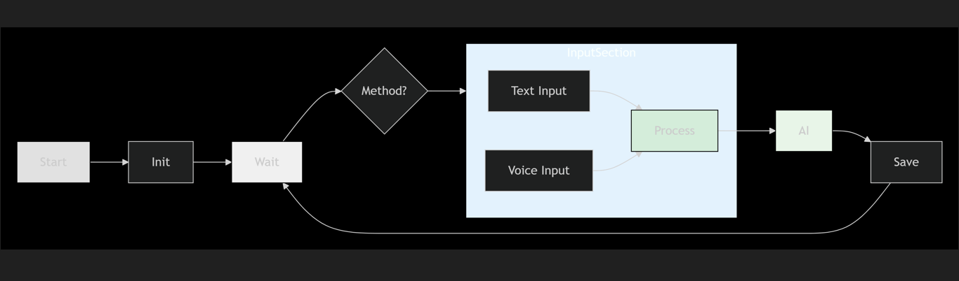
Figure 3.3: Report Generation Workflow (Flowchart/Activity Diagram)
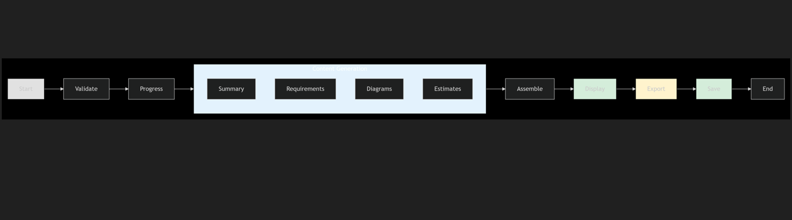Figure 3.4: Detailed Sequence Diagram for Chat Interaction
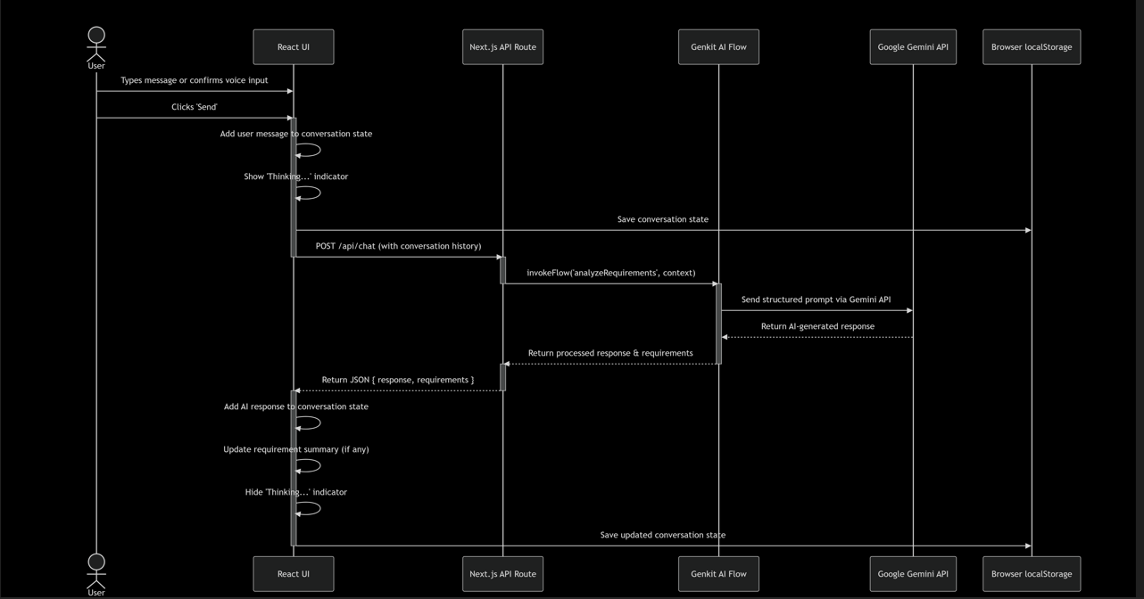
Figure 3.5: Class Diagram
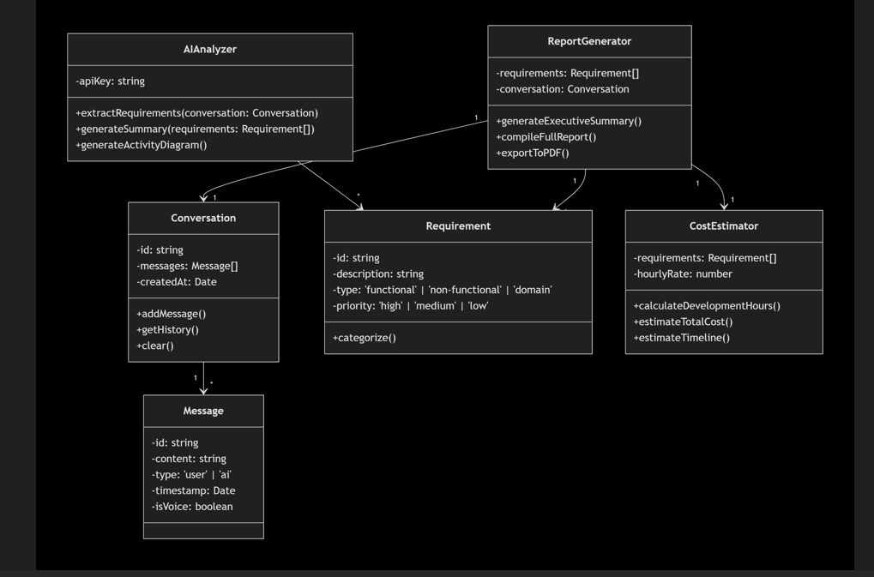
Figure 4.1: Data Flow Diagram (DFD) Level 0
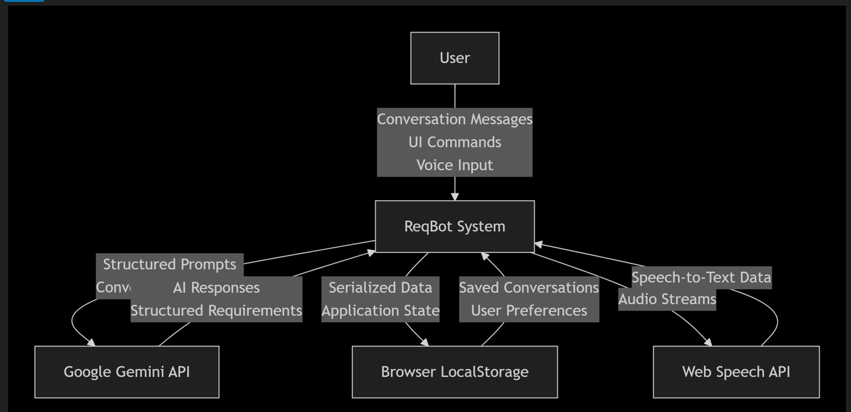
Figure 4.2: Entity-Relationship Diagram (ERD) for Client-Side Data
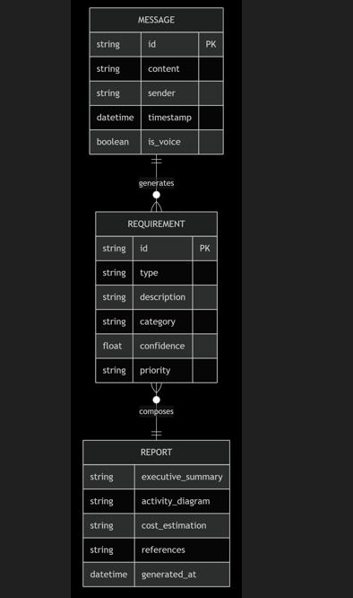
Figure 4.3: Application State Machine Diagram
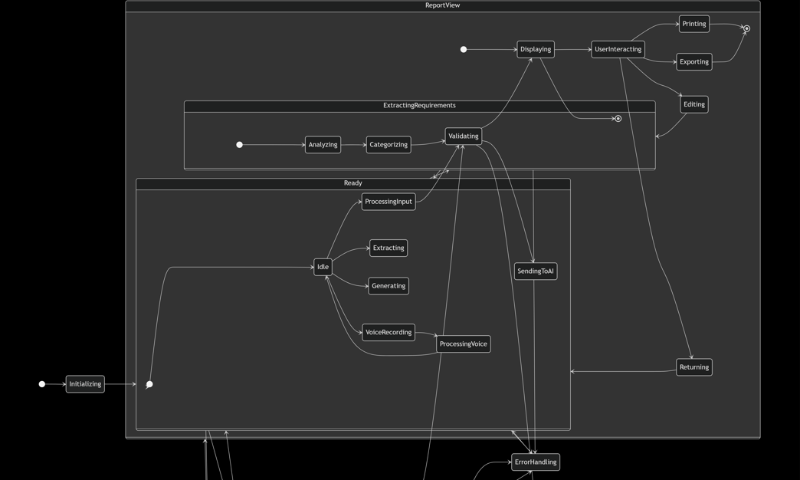 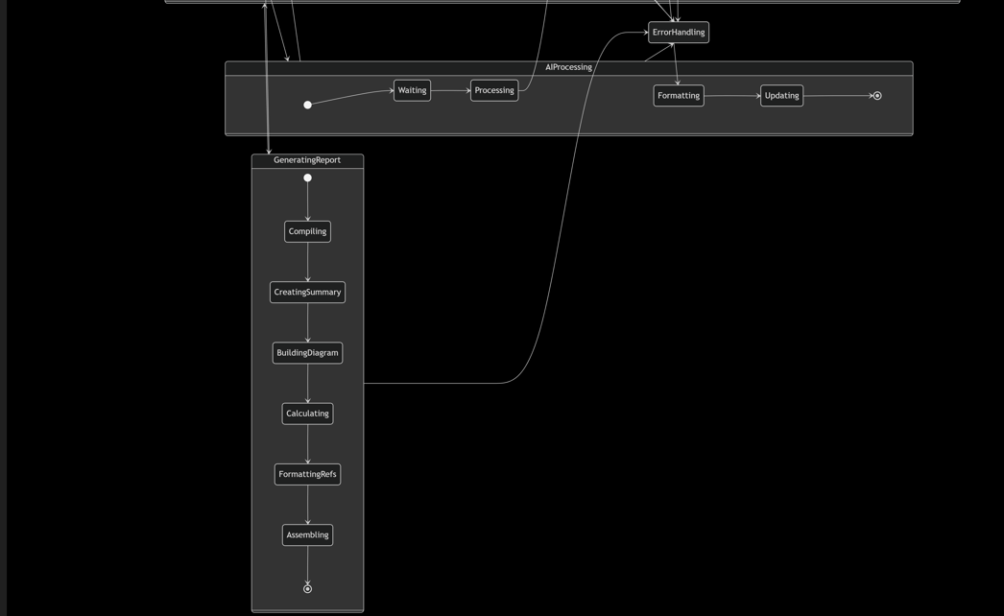
Figure 4.4: Component Interaction/Architecture Diagram
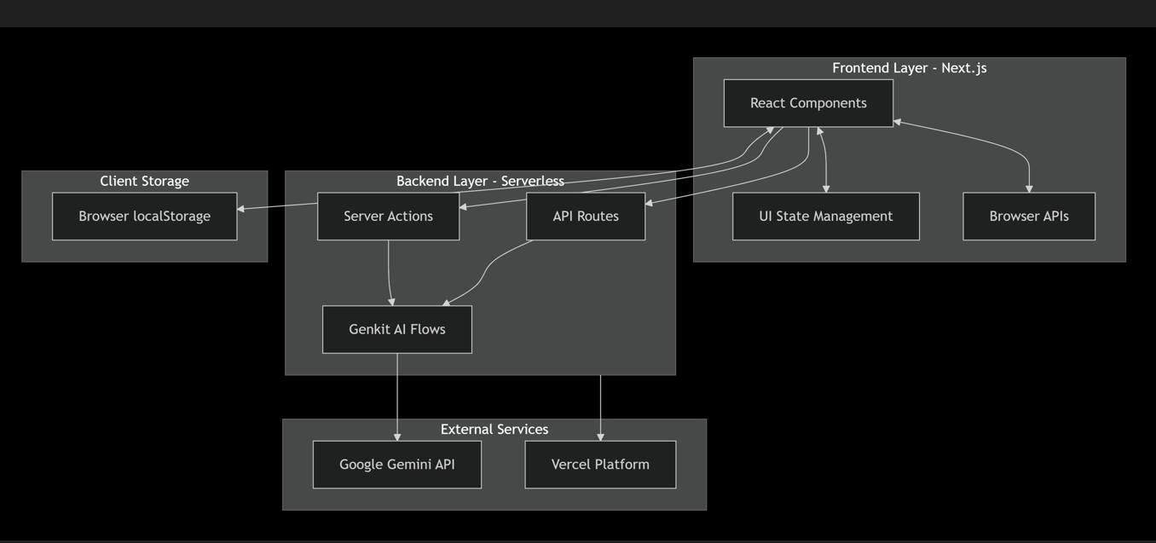
Appendix C: To Be Determined List
TBD Ref. | Description | Owner
TBD-001 | Finalize the specific pricing tier and associated rate limits (requests per minute) for the production version of the Google Gemini API. | Project Manager  (M.WALEED)
TBD-002 | Determine the specific, user-friendly fallback mechanism for the voice input feature when the Web Speech API is entirely unsupported by the user's browser (e.g., display a static message vs. hide the button). | UI/UX Lead  (M.WALEED)
TBD-003 | Finalize the heuristic algorithm and input factors for the speculative cost and timeline estimations in FR-REPORT-3. | Lead Developer  (M.WALEED)
Appendix D: Traceability Matrix
User/Feature | Refined list of functional or non-functional requirements | Link to a refined list of technical requirements | Priority (High, Medium, Low)
All Users / Core Conversation | FR-CONV-1: Provide text input | TC-UI-001: Verify chat input field exists and is focusable on load.  TC-UI-002: Verify message is sent on 'Enter' keypress and button click. | H
 | FR-CONV-3: Maintain conversation history | TC-DATA-001: Verify new messages are appended to the visible chat history.  TC-DATA-002: Verify timestamps are displayed for each message. | H
 | FR-CONV-4: Persist conversation | TC-DATA-010: Verify conversation is saved to localStorage after a send/receive cycle.  TC-DATA-011: Verify conversation is restored upon browser reload. | H
All Users / Voice Input | FR-VOICE-1: Capture audio input | TC-VOICE-001: Verify browser microphone permission is requested on first button press.  TC-VOICE-002: Verify audio data is captured when button is held. | M
 | FR-VOICE-4: Review transcribed text | TC-VOICE-010: Verify transcribed text is placed into input field after recording stops.  TC-VOICE-011: Verify transcribed text can be edited before sending. | H
Business Analyst / Requirement Analysis | FR-EXTRACT-1, 2: Analyze and categorize | TC-AI-001: Submit a sample project description and verify the response contains a list of categorized requirements.  TC-AI-002: Verify requirements are correctly identified as Functional, Non-Functional, etc. | H
Product Manager / Reporting | FR-REPORT-1, 2, 4: Generate summary, diagrams, format | TC-REPORT-001: Click 'Generate Report' and verify a modal opens with a formatted report containing a summary and at least one diagram.  TC-REPORT-002: Verify the report template uses consistent, professional styling. | H
Product Manager / Reporting | FR-REPORT-3: Speculative estimations | TC-REPORT-015: Verify a report for a complex project contains a non-empty "Estimations" section.  TC-REPORT-016: Verify estimates are labeled as "Speculative". | M
All Users / Performance | 5.1 - AI Response Time < 5s | TC-PERF-001: Measure time from message send to full response display; assert it is < 5000ms. | H
All Users / Security | 5.3 - Data Confidentiality (TLS) | TC-SEC-001: Use a network analyzer to verify all external requests are made over HTTPS. | H
All Users / Usability | 5.4 - Novice user success | TC-UX-001: Conduct usability test with 5 novice users; task: describe a simple feature and generate a report. Success criterion: 80% completion without help.

